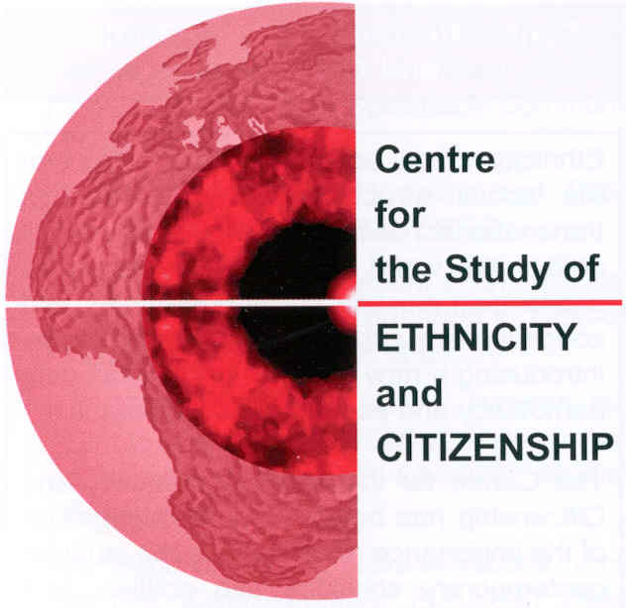




PLURISPACE Conference
Negotiating diversity in European public spaces

Venue: Toynbee Hall (Lecture Hall), London
Date: Monday, 17 October 2022

9.00-9.25 Arrival and coffee

9.25 Welcome

Tariq Modood, University of Bristol

9.30 Conceptualizing European Public Spaces in Relation to Four Diversity Governance Perspectives

John Erik Fossum, University of Oslo
Riva Kastoryano, Sciences Po
Tariq Modood, University of Bristol
Ricard Zapata-Barrero, Pompeu Fabra University
Discussant and chair: Geoffrey Levey, University of New South Wales

11.00 National-Level Governance of Diversity in Four European Countries

Pier-Luc Dupont, University of Bristol
Espen D. H. Olsen, Oslo Metropolitan University
Discussant and chair: Hauke Brunkhorst, University of Flensburg

12.30 – 1.30 Lunch

1.30 Municipal Governance of Diversity

Zenia Hellgren, Pompeu Fabra University
Thomas Sealy, University of Bristol
Discussant and chair: Pnina Werbner, Keele University

3.00 Ethnic Minority Civil Society Perceptions of the Governance of Diversity

Luana Franco Rocha, Sciences Po
Pier-Luc Dupont, University of Bristol
Discussant and chair: Marco Antonsich, Loughborough University

4.30 Tea and arrival of new participants

5.00 – 7.00 Key findings and recommendations for practitioners and stakeholders

Sado Jirde, Black South West Network
Jabeer Butt, Race Equality Foundation
Other speakers to be announced
Chair: Sunder Katwala, British Future

7pm Close/Reception

